Saddleworth Historical Society

FAMILY HISTORY NEWSLETTER - summer 2016

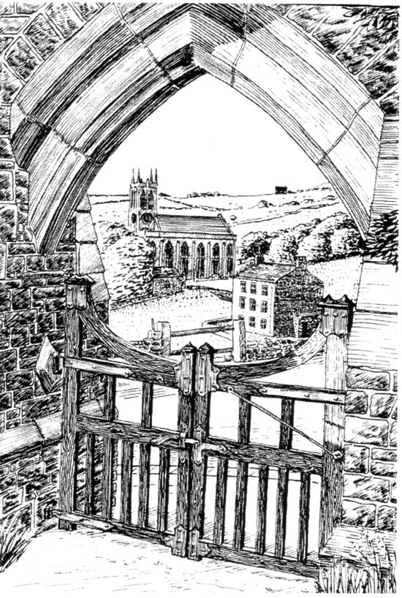

We hope that you will find this newsletter useful

The Mossley and Saddleworth Reporter – 21st June 1940
Councillor B. Dransfield has received a letter from Mr Lawrence Richmond, West Riding County Public Assistance Officer, in appreciation of the gifts of cigarette cards for the orphaned children in the County children’s homes.

Back from Dunkirk
Flags and streamers placed by neighbours across Court Street Uppermill, welcomed Private Herbert Burton, adopted son of Mr and Mrs A. J. Latham of 7 Court Street, Uppermill upon his arrival home from Dunkirk on leave last weekend. Private Burton is a member of Uppermill 1st X1 cricket team and is associated with Uppermill Methodists Church and Sunday school. He rejoined his regiment on Monday.

About shelters
In Saddleworth there are a number of public air-raid shelters and people should memorise where they are situated. These shelters are really intended for people who happen to be in the street when an air raid warning is given. All other people are strongly advised to keep indoors, make for cellars or protected passages and keep away from windows and above all remain calm. Trying to witness the “fireworks” by standing near windows is asking for trouble and a most foolhardy thing is to go out into the streets. At such a time the air raid wardens and the fire brigade would be hampered in their work by the presence of civilians in the streets and roads. If we are unable to help actively in this work of dealing with out breaks of fire and handing casualties, we can at least refrain from hindering those who are carrying out the work.

**********

The Mossley and Saddleworth Reporter – 12th July 1940
A stone bearing the name Bradbury and dated 1801 can be seen in the vicinity of Bills o’Jacks, Greenfield no demolished. The stone was lettered and dated long before the double murder which took place in 1832.

The reduced summer school holidays from one month to two weeks has been disappointingly received by the children in West Riding.

**********
Events of 1940
January – Council adopted scheme of payments for employees of H.M. Forces.
February – Death of Mrs Harriet Bristow (94), Flowery Cottages, Delph, Saddleworth’s oldest woman.
March – Hawthorpe Hall, Uppermill, residence of late Captain W.G. Bagnall, sold by auction for £1,420.
April – Rev. James Hinchliffe, formerly of Saddleworth appointed rector of Christ Church, Wainfleet, Ontario, Canada.
May – Death of Mr John William Liversage (77), Quick Edge, Grotton, former surveyor of Lees District Council.
June – Funeral of Mr Abraham Fielding (63) Armit Cottages, Royal George, former cricketer and footballer.
July – Right Hon. Margaret Bondfield, M.P., visited Uppermill and told women how they could help to win the war.
August – Saddleworth Spitfire fund launched by Councillor A. Wild at council meeting.
September – “Busy Bees” completed 12 months work; made and sent 10 troops over 4,000 woollen garments and raised over £300 for wool and other comforts.
October – Mr G.H. Wild (61) formerly auctioneer at Uppermill and Mossley, victim of London air raid.
November – Saddleworth lighting Committee adopted modified system of “starlight” lighting.
December – Messerschmitt on view at Uppermill.

**********

The Mossley and Saddleworth Reporter – 3rd July 1942
Recently a Saddleworth man was fined 10s for wounding a homing pigeon. Persons caught shooting these birds deserve to be severely dealt with. The homer or carrier pigeon is a valuable and harmless bird, which should be left alone now that many of them are carrying messages of national importance.

Special water from White Wall Springs in Saddleworth is being bottled to be used at a pending christening ceremony.

**********

The Mossley and Saddleworth Reporter – 31st July 1942
The 1st Saddleworth worthies to own motor cars were the late Mr Edward Hollingsworth, the late Mr Jack Taylor (who had an early Rolls-Royce), Mr Ernest Robinson and the Mallalieus of Delph.

The first woman in Saddleworth to drive a motor car was the widow of Mr Jack Taylor (nee Miss K. Bent) who was also the first local woman to fly.

Messrs J. Butterworth and Sons, Road End, Greenfield were the pioneers of garage proprietors and are still one of the most up-to-date firms. The first car to reach to Chew House, Greenfield was an air cooled 8 h.p. Rover.

The first motor car was owned by the late Capt. George A. Schofield of Greenfield in 1901 and bore the registration no B U 5. It was driven by Mr Charles E. Nicholls.

**********
The Reporter – 30th April 1943
*Greenfield Methodist Sunday school will hold its 98th Anniversary Service on Sunday it was established in 1845.

*Street Lighting in Saddleworth is to be discontinued from to-morrow to August 14th in compliance with a Ministry request.

*For the first time for many years the annual Road End Fair Concert at Greenfield Conservative Club, at one time a local Easter attraction, did not take place.

*Without the customary Road End Fair, Greenfield lacked its usual holiday spirit.

The Mossley and Saddleworth Reporter – 19th July 1946
Bread rationing – Views of a Saddleworth baker.
A petition against rationing of bread has been signed by numerous housewives in Greenfield, but bakers in Saddleworth, although rather concerned as to the way the rationing system will work are waiting to see for themselves how things will turn out. One baker, Mr J. A. Greenwood, J.P., of Side Bank House, Greenfield, who has shops in Greenfield and Mossley, tells me that he cannot see how bakers and their staff are going to deal with the rationing of bread, and he does not think it can be a success. “One of my girls”, he said, “Has already become ill at the thought of how more coupons are going to be dealt with. It will need at least one efficient full time assistant to deal with the coupons, and few people in the trade can afford to do this. A country baker,” declared Mr Greenwood, “does not just sell bread like in a big town baker, he has to sell other foods and, consequently, he has all kinds of coupons to deal with, and bread rationing added to this will make things very complicated and difficult to deal with. Some small shopkeepers have decided to stop selling bread if it is rationed, because they cannot deal with the coupons. The sooner the Government realise that they have put their foot into it by trying to ration bread the better.” he added.

**********

The Mossley and Saddleworth Reporter – 22nd November 1946
Mrs Millie Dunkerley, formerly Miss M. Hirst of Greenfield, whose husband Sergeant William Dunkerley of the Canadian Forces, sailed to America on Tuesday.

The Mossley and Saddleworth Reporter – 29th November 1946
Mrs Millie Dunkerley of Greenfield, who was one of the passengers on the Empire Brent when it was damaged in a collision in the Mersey, will sail for America when the liner has undergone repairs.
(Note: Millie Hirst was born on the 17th February 1923 and she married William Dunkerley at St Mary’s Church, Greenfield in 1943. On the 13th December 1946 she did travelled from Liverpool to Halifax, Nova Scotia on S.S. Empire Brent, and then on the 14th December she travelled to Central Falls, Rhode Island, USA to be with her mother-in-law Elizabeth Dunkerley. Millie’s mother, Mary Kenworthy, lived at Burn Bank Lodge, Greenfield)

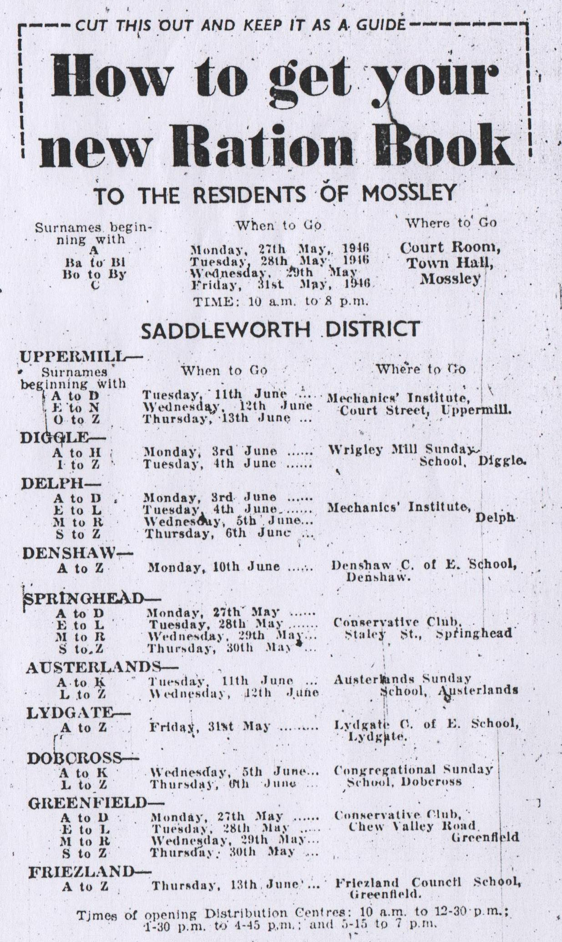

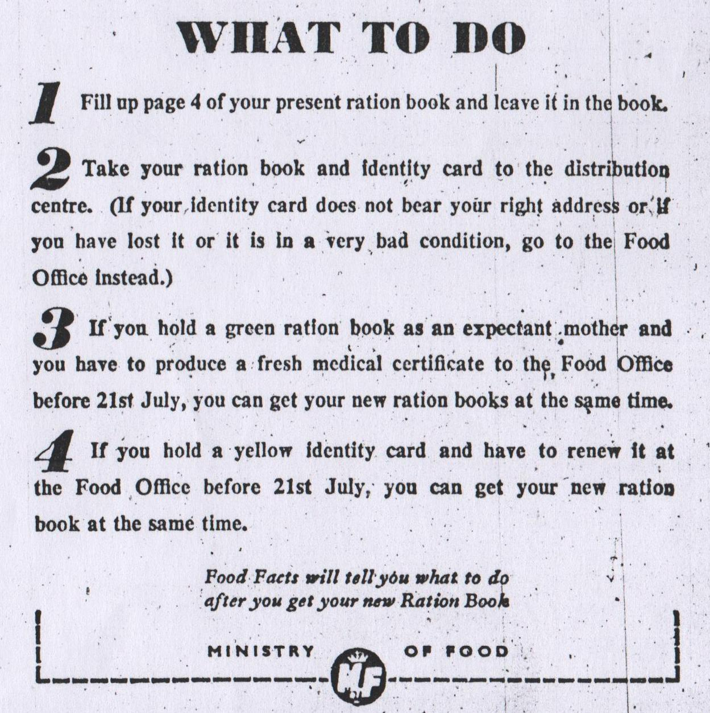

Mossley and Saddleworth Reporter 24th May 1946

